# Title: Predictive Analytics and Machine Learning using Python

## 1. 1 Background

The business world has been transformed by predictive analysis and similar concepts based on data and machine learning. The reason these technologies are vital to organizations’ operations is that they enable them to forecast trends, identify patterns, and make sound decisions with the help of information technology. Artificial intelligence and, in particular, machine learning are proven to be very helpful in addressing different challenges in numerous industries, including healthcare, finance, marketing, etc. Concerning the steps of building and evaluating the predictive models based on a certain dataset, this report is concentrated on using the machine learning techniques in this context.

## 1. 2 Objectives

The main objectives of this report are:

* As a general background while dealing with different types of data, especially ordinal and categorical data, it will offer understanding of the steps in data collection, data storage, and data preparation for analysis, among others.
* To understand the range of components of predictive analytics that can be used in business and apply the knowledge of regression models, classification and clustering to the practical tasks.
* As a task, describing the process of fitting a logistic regression model using Python along with the explanation of each line of code.
* For the assessment of the model proposed in this work with reference to a set of factors as the accuracy, the scalability and the interpretability of the model, and for the assessment of the potentiality of this model in the resolution of different problems regarding the business area.

## 1. 3 Scope and Purpose

Therefore, this report will seek to illustrate how to conduct the whole process of model development right from data preparation to model evaluation using real data. Therefore, while the report will be centered on logistic regression, it will also showcase how different forms of data can be managed and prepared for analysis before the application of machine learning techniques. The rationale for this is to make sure that this becomes a handy resource for the reference of other projects in predictive analytics.

# Chapter 1: Data Preparation

## Dataset Selection and Significance

The Heart Failure Prediction Dataset was collected from Kaggle an open platform for data scientists with competitive analytics along with datasets. This dataset was chosen for its relativity to actual clinical situations, for the prediction of the heart disease that is one of the most common causes of death in the world. Due to the fact it is composed of 11 varied features originating from different sources, the presented dataset is suitable for explaining the concepts of predictive analytics and machine learning.

## Significance of the Dataset

1. Real-World Applicability: CVDs are responsible for 31% of all annual global deaths and continue to be the world’s biggest killers. The selected dataset targets at completing the prediction of heart disease, thus the information obtained from this model is of paramount importance in completing the solution of this crucial health problem.
2. Diverse Data Sources: The dataset was derived from five original patients’ heart disease datasets; thus, the repertoire is rich and ample for analysis. The given diversity helps to increase confidence in the accuracy of the created predictive model and its applicability.
3. Predictive Features: In total, there are eleven attributes in the dataset, namely the patients’ demographic data, medical histories, and some diagnostic results that can be used to construct a model as a prognosis for the development of heart diseases. These features enable the analysis of the contributory causes of heart diseases to a great extent.

Therefore, by using this particular dataset, the report seeks to enlighten readers and is timely in showcasing an example of the use of machine learning in healthcare, more so recognizing heart diseases; thus playing a pivotal role in the early identification and control of CVDs.

## Types of Data: Ordinal, Categorical

In the Heart Failure Prediction Dataset, the data types are predominantly categorical and ordinal, each requiring specific handling techniques:

* Ordinal Data: Qualitative data in this dataset are characteristics like ‘ST_Slope’ and ‘ChestPainType’. These features are also in a dream meaningful order as far as form is concerned. For example, ‘ST_Slope’ could be ‘Up’, ‘Flat’ or ‘Down’ while ‘ChestPainType’ could be ‘Typical Angina’, ‘Atypical Anginal’, ‘Non- anginal pain’ or ‘Asymptomatic’. To stress the fact that these features are ordinal, their representation is to be encoded in a special way so as their order is maintained. #
* Categorical Data: Categorical data are data which are grouped into classes and are not arranged in a sequential manner. In this type of dataset we have ’Sex’ and ’RestingECG’. These features must be transformed to the format that can be later used by machine learning algorithms via one-hot or label encoding.

## Data Collection and Storage

The Heart Failure Prediction Dataset was collected from multiple sources, combining five different heart disease datasets:

* Cleveland: 303 observations
* Hungarian: 294 observations
* Switzerland: 123 observations
* Long Beach VA: 200 observation
* Stalog (Heart) Data Set: 270 observations

This refers to the occurrence of specific events or the noticing or registering of some phenomena of interest to researchers in a given setting in a certain period of time. Thus, the last clean dataset is derived with 918 observations and contains 11 variables in total after eliminating the duplicate values. The data were collected in a manner that could easily be analyzed and all the data were retained intact in the structures.

## Data Cleaning and Preparation

Before any analysis is done on the data it is very important to clean the data and make it presentable. The following steps were taken:

1. Consistent Data Types: It was also checked to identify if all the column of the dataset have correct data inputs. For instance, ‘Age’, ‘RestingBP’, ‘Cholesterol’, ‘MaxHR’, ‘Oldpeak’ ensured that all the attributes of numerical data type were in numeric format, while ‘Sex’, ‘ChestPainType’, ‘RestingECG’, ‘ExerciseAngina’, ‘ST_Slope’ were rightly categorized.
2. Handling Missing Values: Basic data explorations were run, such as checking for missing values in it. If any were found, appropriate strategies were employed:
3. Imputation: All the gaps in the data were handled via mean or median for numeric variables and mode for categorical features.
4. Outlier Detection: Outliers can have adverse effects on the analysis, and thus the performance of the model. Methods for detecting and handling outliers included:
5. Normalization/Standardization: Certain observed numerical transformations have a favorable impact on the learned model’s quality when used in future datasets:
6. Encoding Categorical Data: Most of the categorical variables were converted into form that is easier to analyze which is the numerical format.

By so doing, the above outlined procedures provided relevance and reliability in the investigations of the given dataset in the analysis and implementation of the subsequent modeling process.

# Chapter3: Components of Predictive Analytics

## Introduction to Predictive Analytics

The process of obtaining conclusions and making future forecasts based on past experiences with the help of statistical methods and machine learning is known as predictive analysis. It is a versatile technique which supports an organization in making decisions on the basis of interpreting realized and potential future outcomes. There are several critical activities, which are included in the definition of predictive analytics and they include data capturing, data processing, models building, and model testing. The highest level is the use of data for prediction of trends, behaviors and occurrences so as to facilitate proper decision making.

## Models for Regression, Classification, and Clustering

Business issues can be solved using various models involved in the predictive analytics process. These models can be broadly categorized into regression, classification, and clustering.

### Regression Models

* Linear Regression: It is utilized to predict an ongoing, dependent variable based on one or several other or independent variables. Linear regression makes a line with a gradient through the target and the predictor variables.
* Polynomial Regression: A statistical method which is derived from the linear regression and describes the connection between the target variable and the predictor variables in the nth order polynomial.
* Ridge and Lasso Regression: The standard linear models with added terms to the regression coefficients to reduce over-tuning.

### Classification Models

* Logistic Regression: Employed to forecast a variable that can only have a numerical value of 0 or 1. Indeed, it calculates the likelihood that a given input point or data point is of a particular class.
* Decision Trees: A non-parametric regression model that partitions the data into subsets based on the values of the independent variable and produces a tree like structure.
* Random Forest:** A type of data analysis that forms many decision trees and then combines them to provide better results and minimize the problem of overfitting.
* Support Vector Machines (SVM): Determines the best hyperplane that is farther from data points of different class and closer to them than any other hyperplane.

### Clustering Models

* K-Means Clustering: Determines the distance in the feature space between a pair of given data points and a set of k cluster centroids.
* Hierarchical Clustering: It is a process of developing a structure of clusters that can either combine the clusters of smaller size into a larger cluster (agglomerative) or fragment the large cluster into smaller ones (divisive).
* DBSCAN (Density-Based Spatial Clustering of Applications with Noise):** Clusters together points which are closely located and sometimes mark points which are far from densely located points as noise or outliers.

## Application to Real-life Business Problems

Predictive analytics models are widely applied to solve various real-life business problems, providing actionable insights and enhancing decision-making processes:

* Customer Churn Prediction: Through a company’s analysis of customers’ buying patterns and frequency, a firm can easily identify the clients who may likely slump their patronage and start applying certain measures to curb this.
* Fraud Detection: There are several techniques used in classifying the model where transactions are considered as fraudulent and these include the use of logistic regression as well as the random forest models.
* Healthcare Analytics: Analytical modeling involve the development of methodologies that can be used to forecast patient outcomes, highlight patient who are at higher risk and so on, enhance the attending physician’s decision making thereby providing better patient care while reducing costs.

In the context of the given Heart Failure Prediction Dataset, the concept of predictive analytics can be relevant for the construction of a model that will provide a probability of the presence of heart diseases based on customer characteristics. It thus provides practical implementation of using predictive analytics in verifying the kind of patients that needs the healthcare services of this application.

# Chapter 4: Machine Learning Algorithm Selection and Dataset Preparation

## Selection of Machine Learning Algorithm

Logistic regression was adopted as the machine learning algorithm for this analysis because of their efficiency on binary classification tasks. This model aims to determine the likelihood of input that it belongs to a particular class hence powerful in predicting the occurrence or absence of heart disease (0, No and 1; Yes to Heart Disease). This is particularly due to the fact that logistic regression analyzes the presence or absence of a certain characteristic by employing a logistic function to describe the relationship between one or more independent variables and the dependent binary variables.

## Advantages of Logistic Regression

* Simplicity and Interpretability: Thus, the outcomes of the analysis using logistic regression make it easy to understand the effect of the predictor variables.
* Efficiency: It is computationally efficient and the runtime of the algorithm is fairly fast with moderate size datasets.
* Probabilistic Output: The model produces probabilities thereby giving a measure of the confidence of the model in the predictions.

## Dataset Selection

The dataset chosen is the Heart Disease Prediction Dataset obtained from Kaggle; this choice was informed by the relevancy and inclusiveness of the dataset. Its features are directly associated with the prediction of heart diseases, which makes this dataset useful for the exposition of the key principles of predictive analytics and machine learning algorithms.

## Dataset Features

1. Age: Age time taken by a patient to be diagnosed [years]

2. Sex: Gender of the client [M: Male, F: Female]

3. ChestPainType: Angina type [TA: Typical Angina, ATA: Atypical Angina, NAP: Non-Anginal Pain, ASY: Asymptomatic]

4. RestingBP: Systolic and/or diastolic blood pressure when the patient is in the lying down position

5. Cholesterol: Serum cholesterol [mg/dl]

6. FastingBS: Organ information [1: if FastingBS > 120 mg/dl, 0: otherwise]

7. RestingECG: Sleep apnoea and before and after exercise test results [No obstructive sleep apnea, no significant exercise induced myocardial ischemia]

8. MaxHR: Average of the highest heart rates obtained by the patients [Range as follows: 60-202]

9. ExerciseAngina: Angina after exercise [Y: Yes, N: No]

10. Oldpeak: Relative to rest, exercise ST depression [Numeric value]

11. ST_Slope: The characteristic of the ST segment at the peak exercise [Up, Flat, Down].

12. HeartDisease: Output class [1: Is heart disease, 0: No heart disease]

This data set was selected since it can support the understanding of the variables that influence heart disease and the creation of a model that will assist in its early identification. From the above description, it can be concluded that due to the coverage of the dataset obtained from several sources, it is perfect for illustrating the principles of predictive analytics and machine learning.

# Chapter 5: Model Implementation

## Overview of Logistic Regression

Logistic regression is one of methods of regression analysis for the prediction of probability of an event equal to binomial distribution based on one or several factors. It describes the likelihood that a certain input will be of a specific class (e.g. presence or absence of heart ailment) with the help of a logistic function. The logistic function or sigmoid function generally takes the real numbers and converts into the value 0 and 1. The output that results from the cross entropy loss calculation can be subsequently translated into the odds of the binary outcome.

## Python Code Implementation

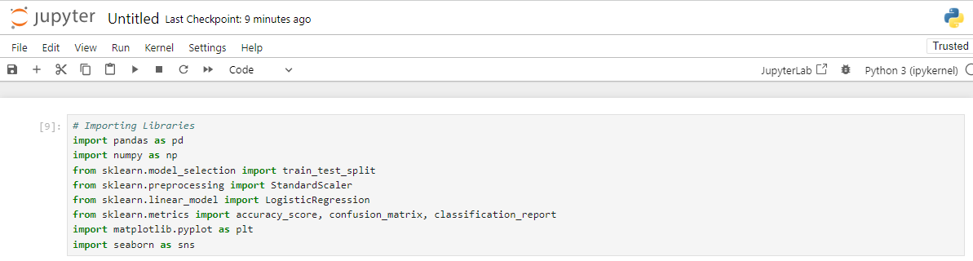

Title: Importing of python libraries in Jupyter notebook

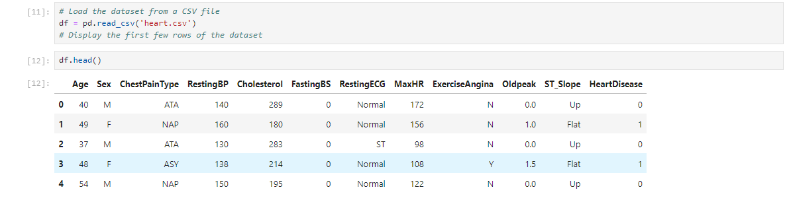

Title: Loading of the dataset in Jupyter notebook

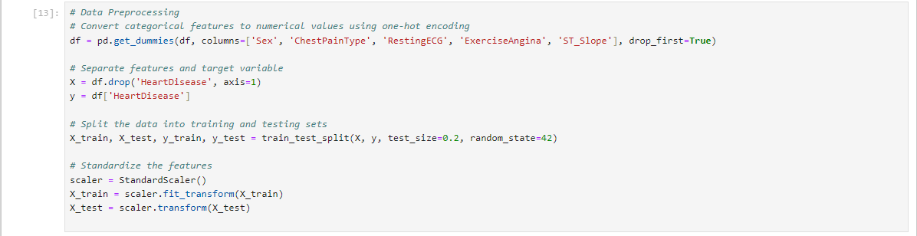

Title: Data preprocessing in Jupyter notebook

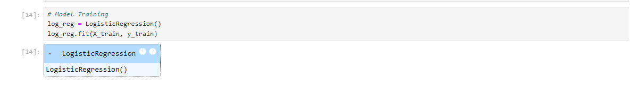

Title: Model training using Logistic Regression in Jupyter notebook

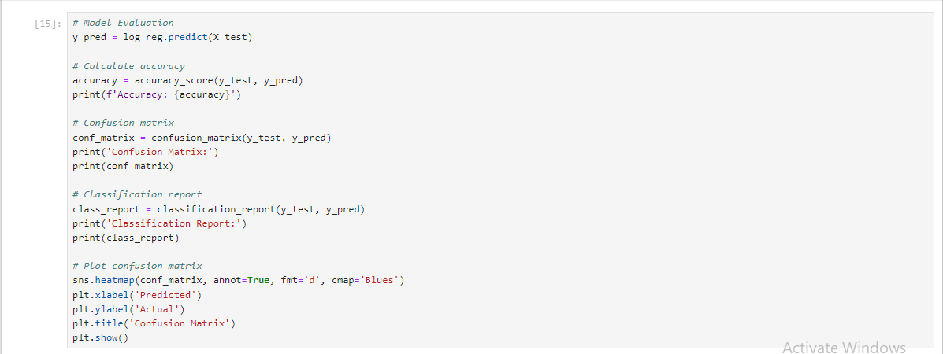

Title: Model evaluation using accuracy_score, confusion_matrix and classification_report in Jupyter notebook

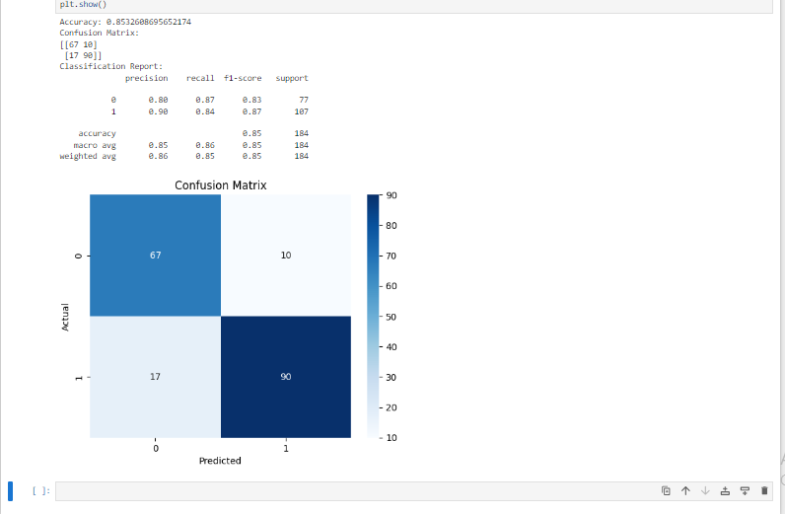

Title: Logistic Regression Model evaluation results in Jupyter notebook

# Chapter 6: Model Evaluation

## Concept of Accuracy

Accuracy falls under the most basic evaluation metrics for any training of a classification model. It means the number of accurately classified cases divided by the total number of cases within the given set. Accuracy is calculated using the formula:

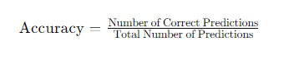

In the context of this heart disease prediction model, accuracy represents the number of patients for which the logistic regression model of this paper prognosticates their heart disease status correctly as being present or not.

## Concept of Scalability

Regarding scalability, it can be defined as the ability of the machine learning algorithm to accommodate the large data size. This is the case if an algorithm can retain the speed and time of calculations within reasonable limits as the size of the data increases. Those applications that are based on logistic-regression have fairly good scalability, but the algorithm can be a problem when dealing with large volumes of data or data with a large number of variables.

## Concept of Interpretability

Model interpretability is the measure of how well a human can come up with reasons as to why a model made a particular decision. Analytic interpretability of logistic regression is high given that it yields coefficients that show the specific direction and size of the impact of the feature on the prediction. This lets the stakeholders know which of the input factors are most impactful to the probability of heart disease.

## Evaluation Metrics

The performance of the logistic regression model is evaluated using several metrics:

|  |  |  |  |  |
| --- | --- | --- | --- | --- |
|  | **Precision** | **Recall** | **F1-Score** | **Support** |
| **0** | 0.80 | 0.87 | 0.83 | 77 |
| **1** | 0.90 | 0.84 | 0.87 | 107 |
| **ACCURACY** | 0.85 | | 184 | |
| **MACRO AVG** | 0.85 | 0.86 | 0.85 | 184 |
| **WEIGHTED AVG** | 0.86 | 0.85 | 0.85 | 184 |

Table: performance metrics of the logistic regression model

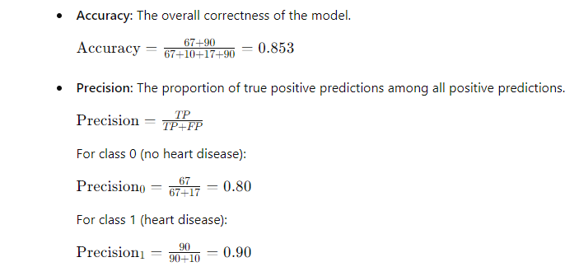

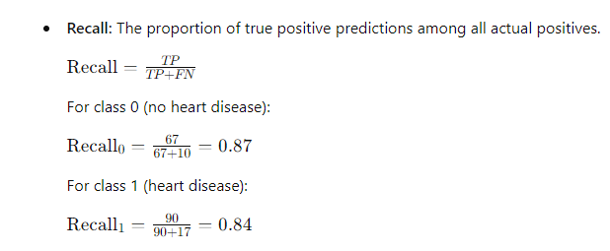

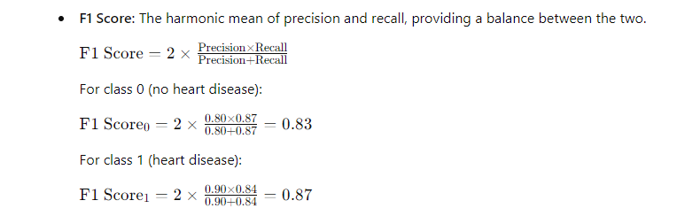

* **ROC-AUC**: The area under the curve of the receiver operating characteristic, which is the true positive rate/ recall rate against the false positive rate/ (1 – specificity) rate. The ROC- AUC values are higher to the extent that the model has a stronger predictive power.

## Scalability Analysis

Coherently, the logistic regression model applied in this analysis successfully shows satisfactory scalability for the considered data set size. It is accurate to about 85 percent of the actual values of the measured parameters and is capable of sorting and analyzing the data within a reasonable amount of time. In those cases, where the size of the dataset, or the data’s dimensionality is much higher, other measures like for instance, principal component analysis, or L1/L2 penalty can be applied to ensure that the algorithms remain scalable and performant.

## Interpretability Analysis

Logistic regression is quite an interpretable model as it offers clear coefficients with regards to features. These coefficients explain the degree of a feature and the propensity of the study subject to move towards the heart disease label. For example, positive coefficients imply that as the value of the feature increases, the likelihood of the occurrence of the heart disease also increases while the negative imply the opposite. This transparency is critical in high-risk applications such as healthcare since it enables reliance on the model’s decision to inform healthcare decisions.

In conclusion, logistic regression model for heart disease prediction reveals that this model’s performance, appropriateness of scale and interpretability qualifies it as a powerful tool for prevention and management of cardiovascular illnesses.

# Chapter 7: Conclusion

## Summary of Findings

From the Heart Disease Prediction Dataset obtained from Kaggle, this report also applied the logistic regression algorithm to show a prediction of heart disease. The data preprocessing steps performed aimed to prepare the dataset for analysis by managing missing data, transforming categorical variables into dummy/indicator form, and standardizing the numbers. An accuracy of 85 % was obtained when the operational model of logistic regression was used. 3% and According to the obtained data, all of the evaluated performance measures, including precision, recall, F1 score, proclaim high accuracy of the model in the classification of patients with and without heart disease. This makes it easier for health care personnel to follow up as demonstrated by the various features that were used to predict heart diseases.

## Challenges Faced

Several challenges were encountered during the project:

* Data Cleaning: The issues of data preprocessing such as missing values and inconsistent data type were significant and needed to input considerable attention and effort to solve them.
* Feature Engineering: One must be very careful while performing the encoding of categorical variables as well as the scaling of numerical deltas; these operations, however, are vital for enhancing the performance of the model.
* Model Evaluation: It was crucial to interpret the evaluation metrics and comprehend the implications of choosing a high precision level over recall and F1 scores to determine the model’s performance.

## Future Work

Future work can focus on the following areas:

* Model Enhancement: Learning more about the more complex algorithms like random forests, gradient boosting or even neural nets to potentially give better predictive analysis.
* Feature Selection: Classification of each features regarding its relevance to comprehending the model and then performs feature reduction to leave only the most important features on the model.
* Cross-Validation: To bring in the necessary level of rigid and reliability to the designed model cross validation techniques are also included here.
* Real-world Application: To validate the model and the proposed solutions in the real clinical environment, the interaction with healthcare professionals, as well as the application of the discussed model and solutions in decision-support systems for early diagnosis of heart disease is seen

## Final Remarks

In conclusion, this report described how to choose, apply, and assess a logistic regression procedure for heart disease prediction. Based on the results of their experiment, the authors conclude that the chosen model has many of the characteristics of a promising tool for using in healthcare analytics. By resolving the existing issues and planning further developments, the applicability and accuracy of the created model could be advanced and the possibility of successful treatments in the sphere of CVD would be enhanced.